User Story-002

Testcase -002 : Button functionality check

Step1: Navigate to the URL of the opencart site 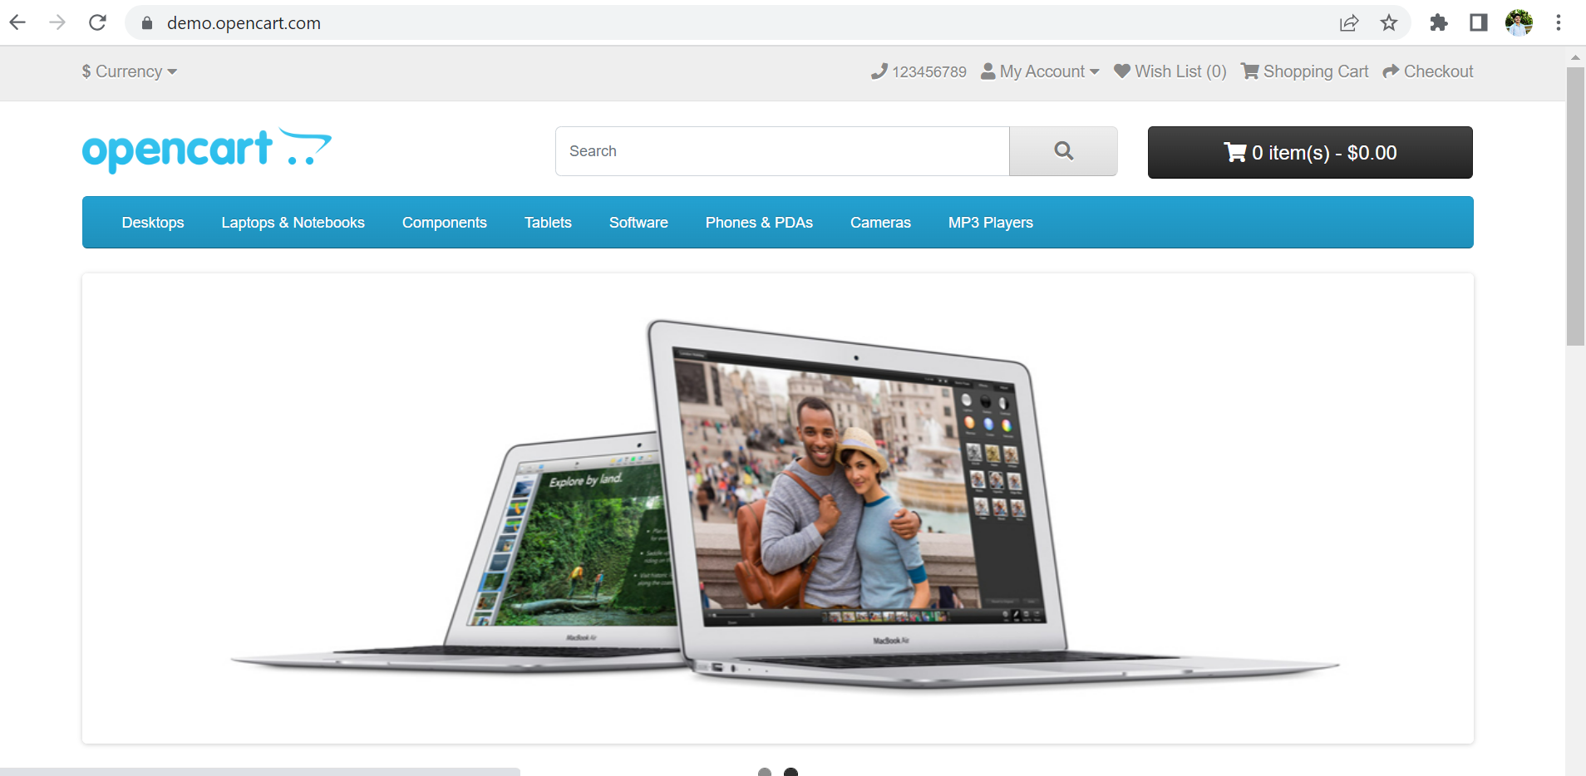

Step2: Click on the entities which are mentioned

**All the steps are not passed and testcase-002 has a defect as its checkout button is navigating to shopping cart entity**